- BACKGROUND
[NAME OF ORGANIZATION] is a private family establishment, founded in August 2013 to fully and actively participate in the Social, Economic re-constructions of Communities in East Africa. [NAME OF ORGANIZATION] perspective is to demonstrate the love of God in a practical means through creativity towards sustainable solutions to social problems. Our mandate lies steadily on promoting Self-reliance to improve livelihood.
- INTRODUCTION
The main opportunity in [CITY, COUNTRY] is the need for safe water. Currently many families fetch water from rivers and the boreholes available has shallow depth drawing majorly water from the River Nile. This River Nile water contain harmful bacterial collected from it long run from Lake Victoria. Causing to those who drink from it to contract water related diseases. 75% of the population suffer from worms, 55% suffer from diarrhoea cases. The biosand filter is a proven technology that can be constructed locally in [CITY, COUNTRY] to help curve the infection.
The people of [CITY, COUNTRY] have been informed to the reason for using Biosand filters and the concept is generally understood. Many of the people have witnessed how the filter works and how it helps families in the nearby towns of Arua and Koboko. A complete single treatment of typhoid cost $41, Bilharzia $14, diarrhoea$8, there is the risk that a person can contract the same disease several times a year.
The BSF can be sold locally at $97 to raise fund for local employees’ incentives. The BSF can produce sufficient safe water for the entire family for more than 25 years and will generate 60 liters of water per day. The BSF units are sold to provide economic independency and sustainability.
- RESEARCH
The purpose of the business is to provide the [CITY, COUNTRY] with safe water within their households. [NAME OF ORGANIZATION]’s partnership with Connect Africa in Uganda have impacted many communities in South Sudan and West Nile sub-region of Uganda. Up to date; the BSF production in Koboko and Arua districts have made the demand for the product to rapidly grows in the neighboring districts as they keep on witnessing the use of the Biosand filters product in many households.
A survey conducted in the entire district in February and March 2020 indicates the following results mentioned below;
According to the 2014 population census Pakwach district has a population of 157,835 and the Uganda Bureau of statistics (UBOS) projected the population of 189,700 in 2019, among them 92,900 are male, 96,800 are female with 162,100 people living in rural areas and 27,600 living in urban areas of the district. Almost 90% of the population uses the river Nile water for all their domestics purposes which contain harmful pathogen. There is no existing BSF business in the area. This has cause household who drink this water to contract worms, typhoid, diarrhoea and other water related diseases. Our survey in the area also shows that a typhoid treatment cost $41, Bilharzia $14 and diarrhoea $8 and about 75% of the population suffer from worms, 55% suffer from diarrhoea cases according to some health Centers, medical Personnel and clinical reports in Pakwach district.
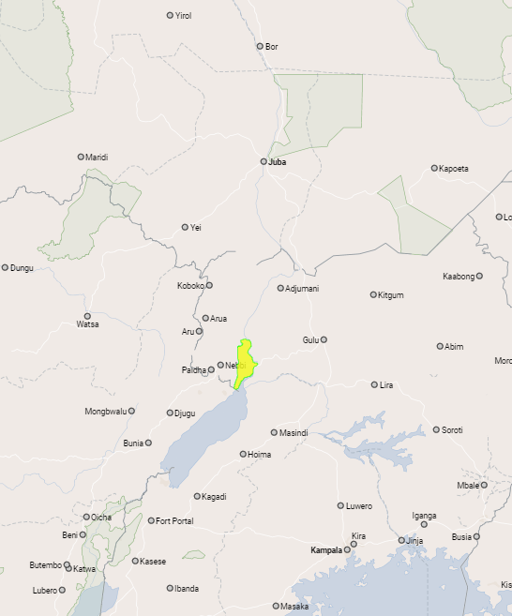

Map of Pakwach District in Uganda (Yellow)
The word has spread to many areas of Pakwach and Community members are interested in owning and using the BSF. Henceforth; the need to consider producing the Biosand filter in the area rather than transporting to the district is to reduce the cost of transporting and damaging the unit to the population in need over a long distant.
- SWOT ANALYSIS
STRENGTH  - Proven success in Koboko, Arua and Neighboring South Sudan  - No business competitions  - Available technical staff  - Demand have been tested and is attractive for BSF sustainability. | WEAKNESS  - Limited Trained personnel (Technician, CHA)  - High start-up capital  - Increase in operational cost as prices of goods fluctuate which will affect cost of BSF.
OPPORTUNITIES  - Willingness of the local government to cooperate  - The high Need for safe water has been identified  - Willingness of the youths learn to become technicians, Community Health Agents (CHA)  - Willingness to pay for the BSF eventually promote sustainability | THREATS  - Higher number of vulnerable citizens  - Staff turnover due to low pay  - High cost of Transportation  - Poor infrastructure  - Fluctuating market of goods  - Cultural beliefs

- PHYSICAL PLAN
The plan number of staff would be one supervisor and two technicians located in Pakwach. The other staff from Arua and Koboko would provide training, management and administrative support. During the initiation period, the manufacturing of the biosand filters will take place in Pakwach district with the construction of production and storage shade approximately 10 square meters. The following equipment will be required for project start;
- Two biosand filter molds
- Three rolls of sieves for separating construction and installation materials
- Trailer motor bike for sales and delivery
- Rolls of ¼ Plastic tubing,
- Mallets and additional tools.

- OPERATIONS
The operation of the project will require raw material consisting of Molds and tools, cement, sand, gravels and miscellaneous supplies for constructing BSF units, transportation cost of the units and Boda-boda maintenance cost. Electronics like computer for record keeping, camera, GPS reader, Printer are required for the operation.
The Purpose of the BSF Project is to reach the gospel and demonstrate the Love of God in a practical way through the provision of Safe water and health education. The following is a brief outline of the activities that will be performed.
- Training of Technicians and Community Health Agents
- Procurement of tools and Gathering of construction material and preparation for use
- Sensitization of the entire community on hygiene and sanitation
- Constructions and installation of Biosand Filters, Education of Biosand filter users continues
- Monitoring or Follow-Up to ensure BSF are used correctly, consistently and continuously.
- Completion Reports

- ADVERTISING
[NAME OF ORGANIZATION] will be advertising through Radio jingle and talk shows, use of posters, words of mouths, public gathering which have been proven methods for community awareness and advertisement.

- MARKETING PLAN
Pakwach communities are aware of the solution to their problem of using the contaminated river Nile water but Kambagiri have put in adequate measures to continuously sensitize the area through the Use of Radios, posters, Community Health Agents (CHA), using the government Village Health Team (VHT). There will be 20% commission from each BSF paid to the CHA, VHT, individual or team who sell a product in cash.
Currently; The BSF have been understood to benefit people who use contaminated water, [NAME OF ORGANIZATION] has plans to sell biosand filters to individuals, institution like schools and health centers/clinics, Charity organizations who support community development and government entities.
In a start up of the project, [NAME OF ORGANIZATION] has plans to produce 2 BSF units a day for 20 days per month with a total of 40 BSf and has assumed to sell 40 biosand filter in a month, with an estimated revenue of $3,880 per month. (Use the break even analysis tool to determine the break even number for you project, as this number will change depending on the costs associated with your facility, staff, payment structure, and manufacturing costs).
- FINANCIAL PROJECTION
The financial projection of BSF has been calculated as below. The assumption is that;
- 40 BSF units are produce every month, it has been assumed that 40 products will be sell out within the month estimating product sale and installation of 10 filters per week.
- The project will initiate with 1 supervisor and 2 technicians (3 employees) with basic renewable contract.
- The office and production site of the project will be on a monthly rent and in 1 and half year the business shall acquire an own permanent site with build shade and office.
- Ultimately families receiving sponsored filter will pay an extra $6 per each BSF unit as Ownership Cash Fund (OCF). While those receiving discounted BSFs pay the subsidise 50% of the remaining cost.
- There will also be individuals who pay 100% of the BSF cost.

APPENDIX A - START-UP CAPITAL (1 Month)
Material/Equipment | Rate | Amount
Shade construction |  | $ 695
3 Technicians & 3 CHA Training |  | $ 2,000
BSF Molds |  | $ 2,150
Sieves |  | $ 83
Materials for first 40 BSF |  | $ 1,175
Computer |  | $ 940
Solar Batteries |  | $ 663
Printer |  | $ 225
Motorcycle |  | $ 1,658
Incentives |  | $ 440
Office rent |  | $ 84
TOTAL |  | $10,113

APPENDIX B – FINANCIAL PROJECTION
REVENUE | F | C | JAN | FEB | MAR | AP | MAY | JUNE | JULY | AUG | SEP | OCT | NOV | DEC
 |  | $ | USD | USD | USD | USD | USD | USD | USD | USD | USD | USD | USD | USD
100% Purchases | 12 | 97 | 1,164 | 1,164 | 1,164 | 1,164 | 1,164 | 1,164 | 1,164 | 1,164 | 1,164 | 1,164 | 1,164 | 1,164
50% Discount | 20 | 48.5 | 970 | 970 | 970 | 970 | 970 | 970 | 970 | 970 | 970 | 970 | 970 | 970
Sponsored | 8 | 97 | 776 | 776 | 776 | 776 | 776 | 776 | 776 | 776 | 776 | 776 | 776 | 776
OCF on Sponsored | 8 | 6 | 48 | 48 | 48 | 48 | 48 | 48 | 48 | 48 | 48 | 48 | 48 | 48
TOTAL REVENUE |  |  | 2,958 | 2,958 | 2,958 | 2,958 | 2,958 | 2,958 | 2,958 | 2,958 | 2,958 | 2,958 | 2,958 | 2,958
EXPENDITURE
Variable Cost |  |  | 1,105.8 | 1,105.8 | 1,105.8 | 1,105.8 | 1,105.8 | 1,105.8 | 1,105.8 | 1,105.8 | 1,105.8 | 1,105.8 | 1,105.8 | 1,105.8
Fixed Cost |  |  | 1,162.7 | 1,162.7 | 1,162.7 | 1,162.7 | 1,162.7 | 1,162.7 | 1,162.7 | 1,162.7 | 1,162.7 | 1,162.7 | 1,162.7 | 1,162.7
 |  |  | 2,268.5 | 2,268.5 | 2,268.5 | 2,268.5 | 2,268.5 | 2,268.5 | 2,268.5 | 2,268.5 | 2,268.5 | 2,268.5 | 2,268.5 | 2,268.5
Excess Revenue over Expenditures |  |  | 689.51 | 689.51 | 689.51 | 689.51 | 689.51 | 689.51 | 689.51 | 689.51 | 689.51 | 689.51 | 689.51 | 689.51

Submitted By:

___________________________________
[PROJECT MANAGER NAME HERE]
[NAME OF ORGANIZATION]

